**Agile Delivery Services BPA**

**RFQ ID: RFQ993471**

**Pool 2**

**Evidence Item: D**

**Provided sufficient documentation to install and run their prototype on another machine**

1. **Download code/files from GitHub.**

* In your web browser, navigate to this URL: github.com/incatech-corp/gsa-agile
* Click “Download ZIP” button on bottom right corner of screen:

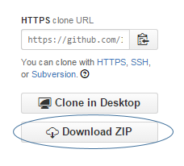

1. **Transfer code package (Step #1) to new machine.**
2. **Unzip code package on new machine.**

* The code/files will need to be placed in the proper location on the new machine. To be accessible from web browsers external to the new machine, the code/files must be place in the web server root directory, or any child folder of the root directory.

1. **Install MySQL on new machine.**

* Download MySQL for your OS here: <http://dev.mysql.com/downloads/>
* Install MySQL on new machine
  + Run installer on new machine (Windows)
  + Run Distribution package on new machine (Linux)

1. **Create database named ‘FoodRecall’ in MySQL on new machine.**

* In MySQL Workbench, click the icon below and follow the instructions.

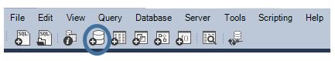

1. **Create table ‘RecallReportItems’ in MySQL on new machine.**

* In MySQL Workbench, run the following script to create the table.

**CREATE TABLE `RecallReportItems` (**

**`recall_number` text,**

**`reason_for_recall` text,**

**`status` text,**

**`distribution_pattern` text,**

**`product_quantity` text,**

**`recall_initiation_date` date DEFAULT NULL,**

**`state` text,**

**`event_id` text,**

**`product_type` text,**

**`product_description` text,**

**`recalling_firm` text,**

**`report_date` date DEFAULT NULL,**

**`voluntary_mandated` text,**

**`classification` text,**

**`code_info` text**

**) ENGINE=InnoDB DEFAULT CHARSET=latin1;**

1. **Create table rows (data) in MySQL on new machine.**

**From the downloaded files in Step #1, navigate to /prototype installation/ folder, and open the Table_data.sql file. Copy contents of this file into Query window in MySQL Workbench. Execute query.**

1. **Access prototype via web browser by using your new machine URL, with additional folder names in URL if files were placed in child folder of Root, and accessing index.html.**